## Steps to open the List example

1. Download listNancy.py and callListNancy.pyw files to the same location as PyQt5.
2. Open the Anaconda Prompt as shown in Fig.1.

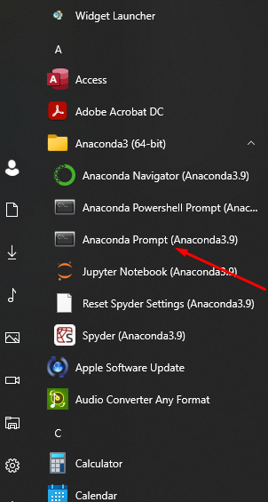

Figure .Open Anaconda Prompt

1. Type idle as in the fig. 2.

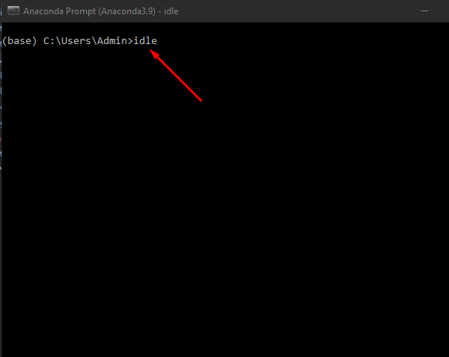

Figure . Type IDLE

1. Click on File and Open the callListNancy.pyw file as shown in Fig.3.

Figure . Open callListNancy.pyw

1. Fig. 4 shows you the content of callListNancy.pyw file, please don’t edit anything and click on Run.

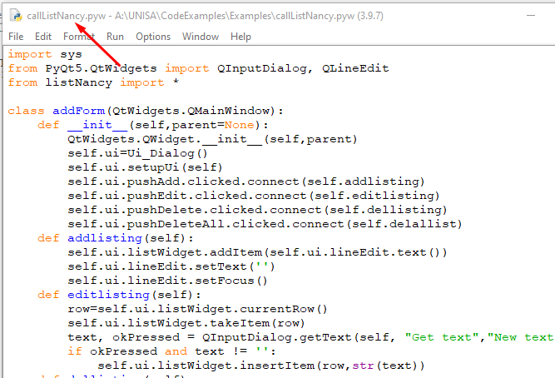

Figure . callLisstNancy.pyw file

1. Click on Run Module as in the following fig. 5.

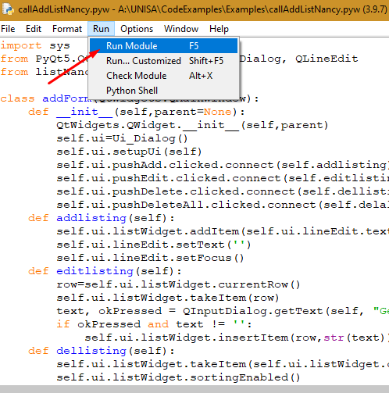

Figure . Run Module

1. Fig.6 shows the dialog after you click on Run Module.

Figure . Dialog after click on Run Module

1. In callListNancy.pyw file, listNancy.py is included in.

Figure . How listNancy.py file include